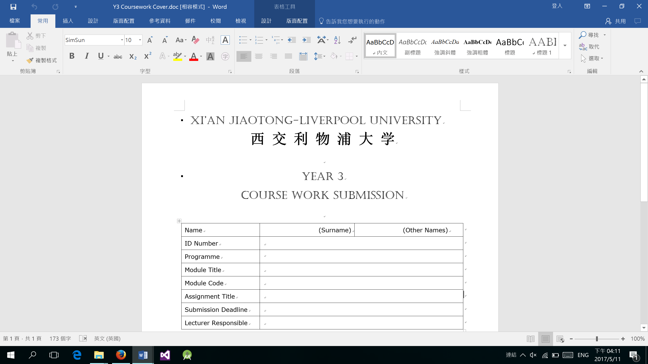

YEAR 4

COURSEWORK SUBMISSION

|  |  |  |
| --- | --- | --- |
| Name | Yuexuan | Li |
| ID Number | *1507955* | |
| Programme | *Information and Computing Science (ICS)* | |
| Module Title | *Principles of Computer Games Design* | |
| Module Code | *CSE310* | |
| Assignment Title | *Individual Assignment 1* | |
| Submission Deadline | *2019/4/13* | |
| Lecturer Responsible | *Hai-Ning Liang* | |

I certify that:

* I have read and understood the University’s definitions of COLLUSION and PLAGIARISM (available in the Student Handbook of Xi’an Jiaotong-Liverpool University).

With reference to these definitions, I certify that:

* I have not colluded with any other student in the preparation and production of this work;
* this document has been written solely by me and in my own words except where I have clearly indicated and acknowledged that I have quoted or used figures from published or unpublished sources (including the web);
* where appropriate, I have provided an honest statement of the contributions made to my work by other people including technical and other support staff.

I understand that unauthorised collusion and the incorporation of material from other works without acknowledgement (plagiarism) are serious disciplinary offences.

Signature ……*.*…………………………………… Date ……*………………………………*……………

|  |  |  |  |
| --- | --- | --- | --- |
| For Academic Office use: | Date Received | Days Late | Penalty |
|  |  |  |